More Induction Examples

Prove the following formula is true for all positive integers n.
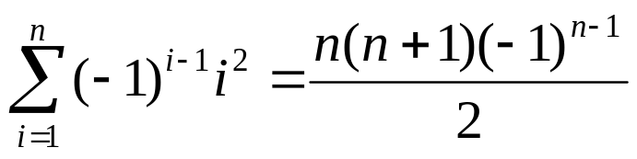
Use induction on n.
Base Case. n=1. LHS = (-1)⁰1¹ = 1, RHS = (1(1+1)(-1)⁰)/2 = 1
Assume for an arbitrary value of n=k that

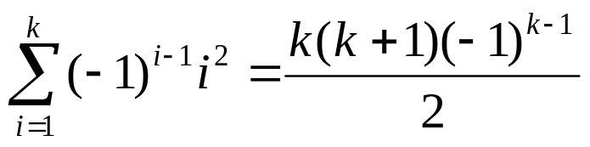

Under this assumption, prove for n=k+1 that

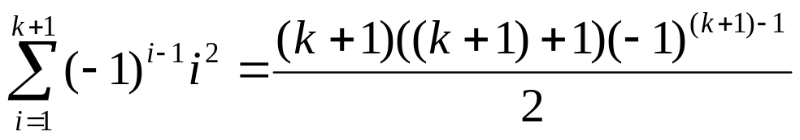

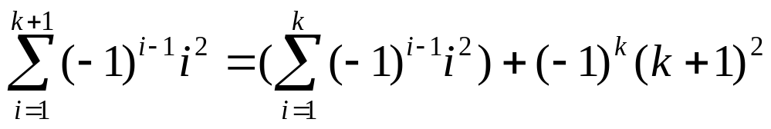

= k(k+1)(-1)^{k-1}/2 + (-1)^{k}(k+1)(k+1),
using IH.
= (k+1)(-1)^{k}[-k/2 + k + 1]
= (k+1)(-1)^{k}[k/2 + 1]
= (k+1)(-1)^{k}(k + 2)/2
= (k+1)(k+2)(-1)^{k}/2
Some Algebra Rules ...

Laws of exponent and Logarithm:

If a > 0, a^{x} • a^{y} = a^{x+y} (a^{x})^{y} = a^{xy}
a^{x} / a^{y} = a^{x–y} a^{–x} = 1/(a^{x})

If b > 0 and b ≠ 1,

log_{b}(xy) = log_{b} x + log_{b} y
log_{b}(x/y) = log_{b} x – log_{b} y
log_{b}(x^{p}) = p log_{b} x.

Rules of inequalities:
a > b ⇔ a + c > b + c
if c > 0, then a > b ⇔ a • c > b • c
if a > b and b > c ⇒ a > c;
if a > b and c > d ⇒ a + c > b + d.

Useful algebra rules:
ab = 0 ⇔ a = 0 or b = 0
if bd ≠ 0, then a/b = c/d ⇔ ad = bc;
(a + b)² = a² + 2ab + b²; (a + b)(a – b) = a² – b².
A couple of summation rules

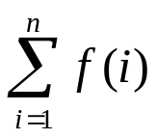 = 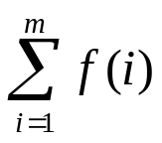 + 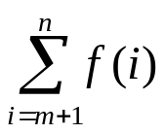, if 1 ≤ m < n.

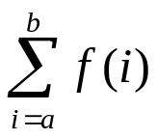 = 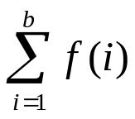 - 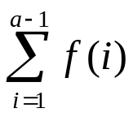, if b ≥ a > 1.

= 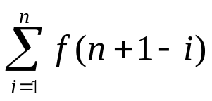

Couple More Examples:

1) Prove 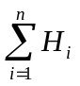= (n+1)H_{n} – n, using induction. Note that H_{n} = 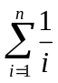

Use induction on n>0.

Base case: n=1. LHS = 1/1 = 1
RHS = (1+1)(1/1) – 1 = 1

Assume for some n=k,

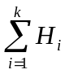= (k+1)H_{k} – k

Under this assumption, we must prove the formula for
n = k+1:

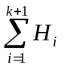= (k+2)H_{k+1} – (k+1)

= () + H_{k+1}
= (k+1)H_{k} – k + H_{k+1}, using inductive hypothesis.
= (k+1)(H_{k+1} – 1/(k+1)) – k + H_{k+1}
= (k+1)H_{k+1} – 1 – k + H_{k+1}
= (k+2) H_{k+1} – (1+k), which completes the induction.

Thus, we have shown = (n+1)H_{n} – n, for all positive integers n.

2) Prove that 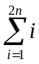= n(2n+1) for all positive integers n.

Use induction on n>0.

Base case: n=1. LHS = 1 + 2 = 3
RHS = 1(2(1)+1) = 3

Assume for some n=k,

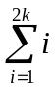= k(2k+1)

Under this assumption, we must show for n=k+1, that

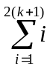= (k+1)(2(k+1)+1)

= + (2k+1) + (2k+2)
= k(2k+1) + 4k + 3, using inductive hypothesis
= 2k² + k + 4k + 3
= 2k² + 5k + 3
= (2k + 3)(k + 1)
= (k+1)(2(k+1)+1),

which completes the inductive proof.
Thus, we have = n(2n+1) for all positive integers n.

Examples of using induction on an inequality

Prove by induction that n! > 2^{n} for all n ≥ 4. (Note: n! = n(n – 1)···2·1, for n ≥ 1; 0! = 1 by convention.)

We use induction on n ≥ 4.

(Base Case) Consider n = 4. In this case,
n! = 4! = 4·3·2·1 = 24, and
2^{n} = 2⁴ = 16 < 24.
So the Basis Step is proved.

(Induction Hypothesis) Consider the statement for some n=k. We will assume that k! > 2^{k}.

(Induction Step) Consider the statement for n=k+1. We need to prove (k + 1)! > 2^{k+1}

(k + 1)! = (k + 1) ·k!,
> (k + 1) ·2^{k}, by the Induction Hypothesis
> 2 ·2^{k} , because k + 1 ≥ 5 > 2
= 2^{k+1} .

By induction, we have proved the inequality n! > 2^{n} for all n ≥ 4.

Use induction on n ≥ 1 to prove the following summation identity:

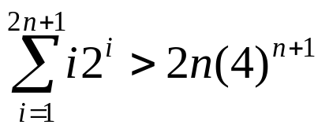

Base Case: n=1. LHS =1(2)¹+2(2)²+3(2)³ = 34
RHS = 2(1)(4)¹⁺¹ = 32, so LHS > RHS.

Assume for an arbitrary n=k that

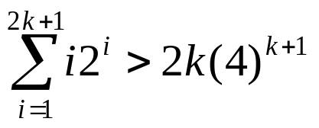

Under this assumption, we must prove for n=k+1 that

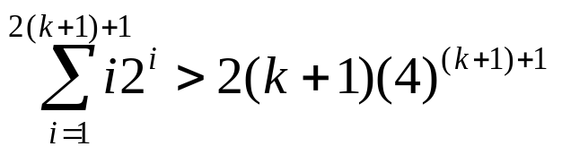

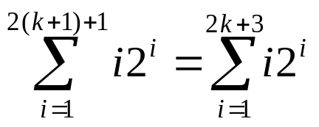

= 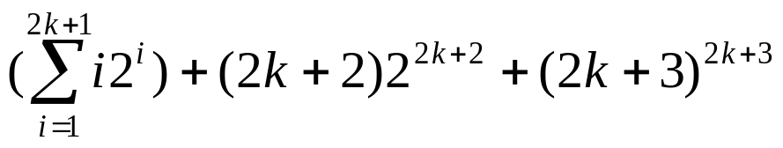

> 2k(4)^{k+1} + 2^{2k+2}((2k+2)+2(2k+3)), using IH.

= 2k(4)^{k+1} + 2^{2(k+1)}(2k+2+4k+6)

= 2k(4)^{k+1} + 4^{(k+1)}(6k+8)

= (4)^{k+1}[2k + 6k + 8]

= (4)^{k+1}[8k + 8]

= (4)^{k+1} (4)(2)(k + 1)

= (4)^{k+2}(2)(k + 1)

=2(k + 1)(4)^{k+2}

Use induction on n to prove the following inequality for all positive integers n:

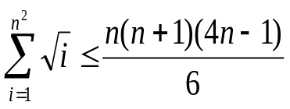

Base Case: n=1. LHS = √(1) = 1
RHS = 1(1+1)(4(1) – 1)/6 = 1

Assume for an arbitrary value of n=k that

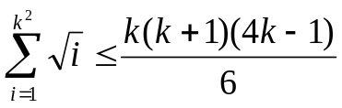

Under this assumption, prove for n=k+1 that

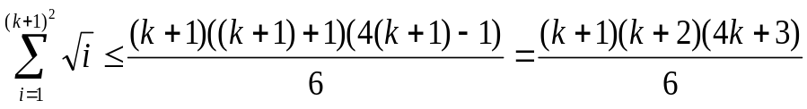

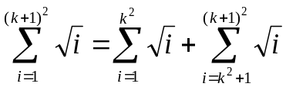

≤ 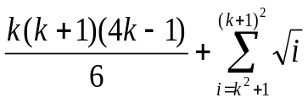, using the inductive hypothesis.

≤ 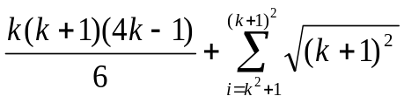,
because each term in the summation is less than or equal to that last term when i = (k+1)².

=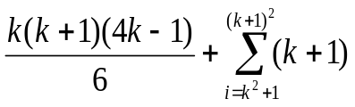

= 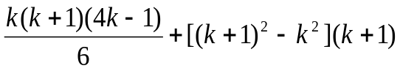 ,

because the first summation from the IH contains k² terms while the summation from the IS contains (k+1)², leaving the
difference for this summation.

= 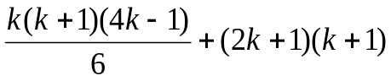

= 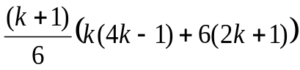

= 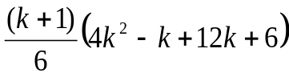

= 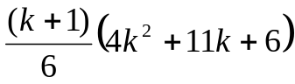

= 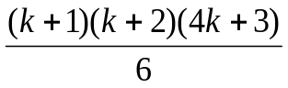
Strong Induction

This works almost the exact same as normal induction, except for your inductive hypothesis changes. In standard induction, the bulk of our proof is establishing the following:

s(k) ⇒ s(k+1), for our open statement s(n).

However, there are some inductive proofs where it is difficult to prove s(k+1) simply by assuming s(k). Perhaps you must assume that both s(k) and s(k-1) are true.

In strong induction, rather than assuming that our open statement is only true for n=k, we will assume that our open statement is true for all values of n ≤ k. So, in essence, we want to know prove the following:

s(m) ⇒ s(k+1), where m is a positive integer such that m ≤ k.

So, a natural question is, do we have to change our base case to use strong induction? The answer is sometimes, but not always.

In our inductive step, if we always have to assume that s(k) and s(k-1) are true, we must have two base cases. Can you see why?

If we have to assume that s(k), s(k-1), and s(k-2) are true, then we must have three base cases.

Sometimes, and I’ll show you when those cases arise, only one base case is necessary.

I will point out examples of strong induction when they come up.
A Fibonacci Number Example

Prove that (F_{n+1})² – (F_{n+2})( F_{n}) = (-1) ^{n} for all positive integers n

Base Cases: n = 1, LHS = F₂² – F₃*F₁ = 1² - 2*1 = -1
RHS = (-1)¹ = -1

n = 2, LHS = F₃² – F₄*F₂ = 2² – 3*1 = 1
RHS = (-1)² = 1

Inductive Hypothesis: Assume for all n ≤ k that
(F_{n+1})² – (F_{n+2})(F_{n}) = (-1)^{n}

Inductive Step: Prove for n = k+1
(F_{k+2})² – (F_{k+3})(F_{k+1}) = (-1)^{k+1}

Since F_{n} = F_{n-1} + F_{n-2} we can say:

(F_{k+2})² – (F_{k+3})(F_{k+1}) = (F_{k+1} + F_{k})² - (F_{k+1} + F_{k+2}) F_{k+1}

= F_{k+1}² + 2 F_{k+1} F_{k} + F_{k}² - F_{k+1}² - F_{k+1} F_{k+2}
= F_{k+1}[2F_{k} - F_{k+2}] + F_{k}²
= F_{k+1}[2F_{k} – (F_{k+1} + F_{k})] + F_{k}²
= F_{k+1}[2F_{k} – F_{k+1} - F_{k})] + F_{k}²
= F_{k+1}[F_{k} – F_{k+1}] + F_{k}²
= F_{k+1}[F_{k} – (F_{k} + F_{k-1})] + F_{k}²
= F_{k+1}(-F_{k-1}) + F_{k}²
= F_{k}² - F_{k+1} F_{k-1}
= (-1)^{k-1}(-1)² = (-1)^{k+1}

